Play Kib DDS Analyse and Shuf-Op http://RogerPf.com/aaBridge
Go to the aaBridge Welcome page. In the left hand column
Click on Play and Kib that page will now show.
On YouTube Play the two videos 004 Using the DDS and Analyser in aaBridge
008 Using 'Shuf Op' and the Analyser in aaBridge
The two videos and some of the earlier topics (chapters) listed in the left hand column of the aaBridge Welcome page, (eg: Practice) have mentioned and show you a little of how to play a hand, try out the DDS (Double Dummy Solver), and use the Shuf Op button.
The task of this document is to fill in any 'blanks' that may not have been covered in the earlier texts.
The Play and Kib entry that you should now be able to see in aaBridge contains a played deal. You can use that as an example hand as you read or use your own.
Move forward to see the first page of the deal (eg: by clicking Flow > once).
Click the Apply Defaults button (real pink dot). Click Enter the Deal
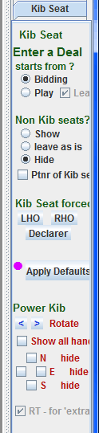
You are viewing a deal. When the deal opened, EITHER aaBridge put you 'inside that deal' OR you have just clicked Enter the Deal.
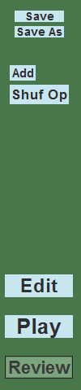

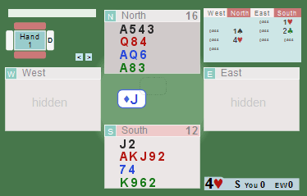

The buttons and components should look something like the above.
Command bar
Step > shows you a trick at a time, instantly displayed.
Flow > shows you a trick at a time, slowly displayed.
> shows you a card at a time.
If you are using a mouse wheel then it will do whichever button you last clicked.
Back to Movie this is the opposite of Enter the Deal – (see 'Down Rabbit Hole'.
in Welcome - Left column)

Left hand Column
Save (and Save As) saves the current Deal to the ‘Saves’ folder .
Raise the lower divider to see additional options.
(See Save 'n' Send in Welcome - Left column).
Add or Rem is covered in doc Lin Files - a Starter.doc.
Shuf Op is covered in the Shuf Op Video.
Edit allows you to change the hand (more on this later).
Play allows you to play the hand (more on this later).
Review is where you are now and can move back and forwards in the play.

Right hand Column
Analyse is covered in the videos – see the first page.
DDS is covered in the videos – see the first page
and see DDS Display Style on the next page
Show / Hide Shows or hides the non Kib Seats.
DDS Display Style (Double Dummy Solver)
One feature of the DDS not covered in the videos is ability to switch between the amber ovals shown in the videos and 'red squares'.
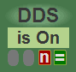
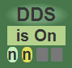
This setting controls how you want the DDS to display the trick numbers it has calculated.
There are two options -- either the default 'amber & green ovals' or the 'dark & green red squares', when the DDS is ON, one of these will show under the is On button. Click in that area to switch to using the other style.
Look at this example taken from within aaBridge
( FYI - it can be found in menubar > Books-T > Boldbida 2016
This is the first deal in that set of hands. )
The contract is 3NT and the Queen of hearts has been led.
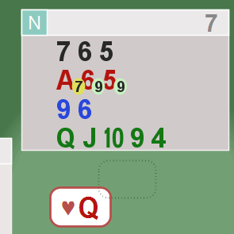
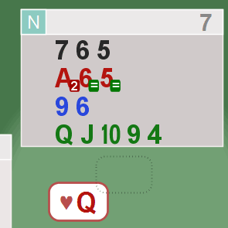

First diagram - the green ovals show you the maximum number of tricks THAT SIDE can make -- in this case 9 tricks, which is the required number for a three no-trump contract.
The numbers in amber ovals show a poorer line of play. The numbers always refer to the SIDE they are on. You need to know ONLY the denomination (here NT) to make sense of the values.
Second diagram - a white equal sign in a green box shows that DECLARER can make the contract if she/he plays this card. A white number in a red box shows they will go down this number of tricks if that card is played. White numbers in a green box (not shown) show the number of overtricks declarer can make.
Here, the numbers always refer to what the DECLARER can make. You need to know both the denomination (here NT) and the contract level (here 3) to make sense of the values.
You may prefer one option over the other.
Kib Seat - FAR right hand column
Enter a Deal – starts from ?
When aaBridge -- enters a deal, this lets you control whether you start by seeing the Bidding or go directly to the Play (and the opening Lead).
Non Kib seats ?
When aaBridge -- enters a deal, this lets you control the initial value of the Show / Hide button (described above) in the green area to the left.
You can force it to 'show', 'hide' or 'leave' it at its current value.
Ptnr of Kib seat set to Always Show
this is most useful when you are reviewing bidding and want to concentrate on just you and your partner's hand.
This setting also takes effect while you are inside a deal, unlike the settings above which only take effect at the moment you enter a deal.
Kib Seats forced to LHO RHO Declarer
Clicking one of these three buttons instructs aaBridge that, whenever there is a valid contract, aaBridge is to rotate the deal so that the chosen seat position is in the South zone.
You will see a small red triangle next to the declarer button whenever this option is active. This is a warning that aaBridge will not behave normally. Click the Apply Defaults button to disable this feature, which also removes the red triangle.
This setting is normally expected to be used when you are inside a deal. Once on, this setting affects all displayed deals, even if you are in a tutorial. If you do wish to play an existing tutorial with one of these settings turned on, you may find that the seat you want to view is currently hidden by the tutorial. You will not be able to see it.
To overcome the above visibility problem you can use the Power Kib setting described later.
Apply Defaults
Resets all Kib Seat setting to the defaults.

Power Kib
Power Kib has three zones
Rotate
The left and right < > arrows provide permanent rotations. These rotations stay in effect when you are inside a deal and when you are in the top level playing a 'movie'.
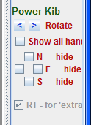
You clear the rotations with the Apply Defaults button or by just clicking the other way.
The LHO, RHO and Declarer buttons above also clear any rotates.
Show all hands
This forces all four hands to be visible. If this is checked, and you can’t see a hand, then there are no cards in that hand.
N E S (W) - Hide
These individual settings override the Show all hands .. For that particular direction. In this way you can hide and show combination of hands. First you show them all and then you hide the ones you do not want.
RT for 'extract...'
This is a setting for the extractMyHands package. See in the document collection, the zip file aa_extract_MyHands__package__vN.NN.zip
It contains full documentation of the package.
In brief - the package allows you to extract up to a month's worth of hands from the BBO MyHands web page. By default, these hands are shown to you automatically rotated so that your hand is always in the bottom (South) zone no matter what direction you were sitting.
When such hands are loaded in aaBridge this option will be enabled. You can choose to unselect it to have the hands treated as perfectly normal single deal lin files, with South in the South zone.
DON'T FORGET
you can always hover over ANY of these SETTINGS to read the TOOLTIP.

Try out the Settings and Features
As was said earlier
The Play and Kib entry that you should now be able to see in aaBridge contains a played deal, you can use that as an example hand as you read on or use your own.

Enjoy your bridge.

<end of document>

